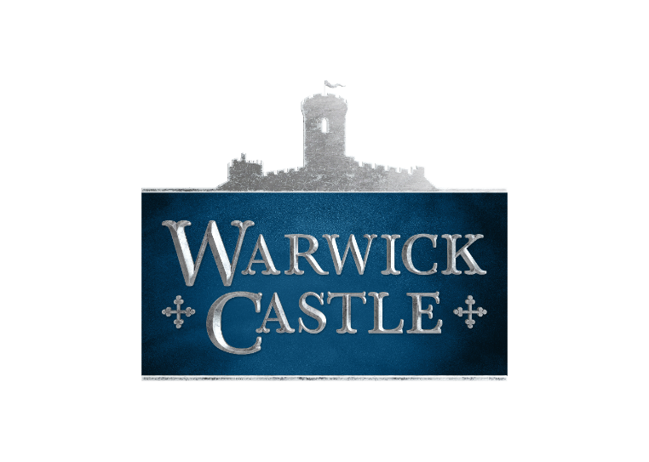

Risk Assessment
Teacher Guidance

Legal requirements and attraction information:
- The purpose of this document is to enable schools / groups to use the information provided for the development of visit risk assessments in order to satisfy the obligations placed by the Health and Safety at Work Act and the Management of Health and Safety at Work Regulations.
- Merlin Entertainments Group does not accept liability for any omissions to this list.
- The control measures indicated are recommendations only and must be adapted / amended by group organisers.
- Please ensure adequate supervisors are appointed for the number in your group, according to Warwick Castle’s stated pupil/staff ratio.

Public Liability
- Warwick Castle is covered by Public Liability Insurance to the amount of £10 million. The policy is with Chubb European Group Limited (Policy No. UKCANC33447).
Local Enforcement Agency Warwick District Council Environmental Health Department.

Food Safety and Hygiene
- All food outlets operate in accordance with the Food Safety Act 1990.
They are regularly inspected by the local Environmental Health Departments.

Attraction Staﬀ Identification
- Apart from oﬃce areas, staﬀ wear uniforms and name badges. Please be aware that some staﬀ will be in costume without name badges.

Security
- The attraction has a dedicated security team, who are able to deal with minor security issues on site. The team is also trained to deal with emergency incidents that may arise.

Risk Assessment Summary
The following hazards have been identified as being inherent to this attraction.

Weather Protection/Sun Safety
- There are areas of shade around the site. There are no general areas to shelter in bad weather other than the main castle building
- Advice on appropriate shoes and clothing should be included in parent communications and provision made for spare clothing.

Wet Weather
- Consider possible weather conditions and have an appropriate plan. Plan for pupils who may not bring suitable clothing – check before departure and/or bring spares. Daily weather forecast obtained, and plans adjusted accordingly.
- Students and Teachers should dress for the changeable British weather. Wet weather provisions inside the castle is limited. All internal areas of the castle will be actively managed in bad weather.

Vehicle Traffic
- The attractions grounds are closed to public vehicles. where there is a requirement for movement on site of internal vehicles, such movement is marshalled by Warwick Castle team members.
- Roads are dearly marked on maps and walkways provided wherever possible. There is a designated drop-off point and entrance for school coaches at Warwick Castle and there is no requirement for children to cross any busy public roads.

Emergency Planning
- Warwick Castle has a contingency plan in the event of an emergency.
- The emergency plan has been developed in conjunction with the local emergency services, which have regular meetings regarding emergency procedures.
- In the event of an emergency, please follow the instructions of Warwick Castle team members who will direct you to an emergency evacuation point. Once gathered the school’s officer will meet with you. update you of the situation and discuss next steps.

Attraction Specific Risk

Slips, Trips & Falls
- All areas of the castle are checked regularly and are kept clear of trip hazards. On wet days, or in the case of spillage, wet surface cones are used. Areas are closed off should they become unsafe, due to adverse weather.
- Stairways are equipped with bannisters and handholds. Signage is in place to warn of uneven surfaces and low doorways.

Reduced Lighting
- The Kingmaker attraction and castle dungeon use reduced lighting as part of the experience.

Castle Ramparts
- School children (under the age of 16) are not permitted on the ramparts without adult supervision.
- Handrails are provided where necessary and barriers and signage are in place to prevent unauthorized access into areas where fall hazards may exist.
- Stairways to the Towers are narrow in places which could cause discomfort to some in your party. A site pre visit is recommended.

Animals on Site
- There are free roaming peacocks on site. They will not harm guests; however, they may react if antagonised. Care must be taken when approaching/photographing these birds and they must be allowed to wander as they wish.
- The Attraction also has a large collection of different birds of prey which are flown during the birds of prey show. This show is actively managed by show marshals and the Warwick bird handlers

Water Danger
- Areas of the attraction's grounds do feature water, for example the River Island. Direct access to the river is prohibited. However, children or students below year 7 must always be supervised when on site.
- Warwick Castle has water safety trained marshals who are present at times of high volume close to the river, e.g. The Falconers Quest show.

Separated from Group
- The Head teacher and Educational Visits Co-ordinator should ensure that the visit lead teacher has been appropriately inducted/ trained and that all staff are competent and understand their roles and safeguarding requirements.
- Ensure that at least one member of staff is with each group of children. Plan and use suitable group control measures (for example, buddy systems, large groups split into smaller groups, each with named leaders.
- Ensure that all group leaders have mobile phones and have telephone number of lead teacher.
- Brief all group leaders on the Warwick Castle lost child procedure, as outlined in the Warwick Castle school’s guidance document, and ensure that children are aware that they should approach a member of Warwick Castle staff, should they become separated from their group.
- The Warwick Castle Safeguarding document is available to download from the school’s website.

Illness or Injury
- There are trained first aiders on site. They should be called by speaking to any member of the Warwick Castle team.
- At least one leader with each school group should be first aid trained.
- Should an incident require the emergency services the call will be made by Warwick Castle.

Specific Needs of Specific Pupils
- (Medical, Behavioural, Educational) In some cases, an individual care plan might require a change in Warwick Castle internal procedures. Such accommodation can be made where this does not affect the health and safety of our other guests and staff. The Warwick Castle schools officer is available to discuss and find solutions to any SEND challenges. You should contact him in advance of your visit. Please inform him of all and any requirements. Schoolsofficer@warwick-castle.com

Indirect/ Remote Supervision
- Warwick Castle permits this type of supervision only for years 7 and above. All other year groups must be supervised according to published minimum Teacher/Student ratios.
- No school children or groups will be permitted to leave the site, without the supervision of an adult school staff member.

- In the case of indirect supervision: Clear guidance must be given to pupils; including contact numbers, rendezvous points and times should be set. Buddy systems should be used with each student being responsible for named other.

Teacher/Adult Helper's Own Children
- If staff or adult helpers' children are included in the visit, group supervision must not be compromised. Children should be of a similar age to school group and supervised with school group or separate supervision arranged.

Wheelchair Access
- Wheelchair access is limited in certain areas of the castle, though access is provided where possible. Access to the ground floor of the main house is made via a wheelchair lift which must be operated by a member of the Warwick Castle team. Should you need to use it please ask any member of staff or contact the school’s officer.

Drinking Water
- You should ensure that children arrive with an adequate supply of drinking water. Should you need to re-fill you will find water fountains around the site

